BILKENT UNIVERSITY ENGLISH LANGUAGE PREPARATORY PROGRAM MATERIALS DESCRIPTION FORM

THEME: Unit 4 Sociology | TITLE OF THE MATERIAL:U4 Vocabulary Revision

Please tick the course package the material will be used in.
- Q Skills Intro | ¨

SKILL: Vocabulary | OBJECTIVE(S) (Tick and fill in as appropriate) Students will be able to  - Practice Unit 4 words

Prepared by: ELPP Instructors

Exercise 1: Match the words in the box with pictures.

find enjoy know ride teach show love paste relax

 |  | 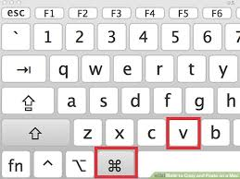 | 
 |  |  | 


Exercise 2: Complete the sentences by using the word in the box. There are more words than you need.
find field enjoy know lake player ride teach show love paste relax complete exciting famous friendly great lazy conversation musician

- You should stop listening to my telephone ........................ .
- The famous jazz .......................... was a composer and a pianist.
- Did you ................. the door key?
- Each ................. takes three cards.
- Our neighbours are very ....................... to us.
- We ................ English to foreign students.
- They ............... the painting to everyone in the galery.
- You need to ................. the application form.
- That’s ................. news. I am so happy.
- The daughter is learning to ............... .
- Cut that paragraph and ................... it at the end of the page.
- I feel depressed. Nothing seems ................ to me.
- Get out of the bed. You are so .............. .
- We went boating on that ....................... .

